Ideation Phase

Define the Problem Statements

|  |  |
| --- | --- |
| Date | 21 September 2022 |
| Team ID | PNT2022TMID51631 |
| Project Name | IOT Based Smart Crop Protection System for  Agriculture |
| Maximum Marks | 2 Marks |

# Customer Problem Statement Template:

Create a problem statement to understand your customer's point of view. The Customer Problem Statement template helps you focus on what matters to create experiences people will love.

A well-articulated customer problem statement allows you and your team to find the ideal solution for the challenges your customers face. Throughout the process, you’ll also be able to empathize with your customers, which helps you better understand how they perceive your product or service.

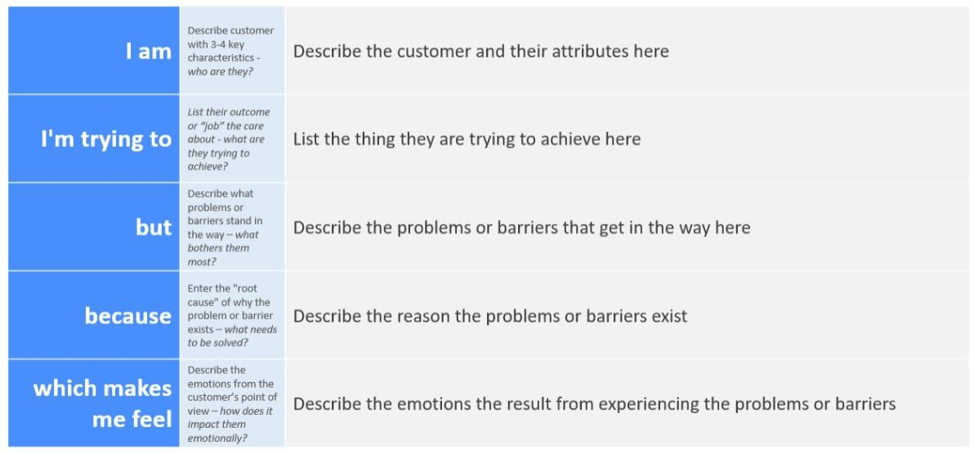

Reference: <https://miro.com/templates/customer-problem-statement/>

# Example:

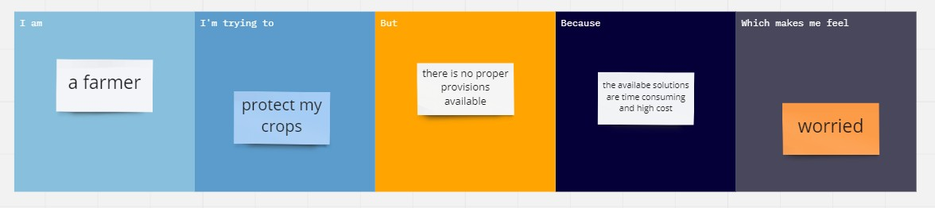

|  |  |  |  |  |  |
| --- | --- | --- | --- | --- | --- |
| **Problem Statement (PS)** | **I am (Customer)** | **I’m trying to** | **But** | **Because** | **Which makes me feel** |
| PS-1 | Farmer | Protect my crops from birds and animals | It is difficult | I live little far from my field , so it is difficult to take actions  quickly | worried |
| PS-2 | Farmer | Plan my farming schedule according to climate | It is difficult for me to predict the climate for the  day | Climatic conditions change rapidly | worried |